Erick Cabrera

ITM 311-02

Lab 04

September 17, 2016

**Purpose:** To create a program that allows you to play a game where you have to guess the random number the program selects.

**Source Code:**

/* Programmer: Erick Cabrera

* Filename: GuessingGame.java

*/

// import a class for random numbers

import java.util.Random;

import java.util.Scanner;

public class GuessGame

{

// method to generate a random number

public static int RandomNumber()

{

// local variable to hold a random number

int rNum = 0;

// a random object is created

Random rand = new Random();

// a random number is generated

rNum = rand.nextInt(20) + 1;

// random number is returned to main()

return rNum;

}

public static void guessingGame(){

int x = 0, guess = 0, response = 1;

Scanner sc = new Scanner(System.in);

//The while loop condition allows the user to

//continue and input another guess if necessary

do{

x = RandomNumber();

System.out.println("I'm thinking of a number from 1-20. What is it?");

guess = sc.nextInt();

while(guess != x){

// tell the user if they are too high or too low

if (guess < x ){

System.out.println("too low ");

System.out.println("guess again:");

guess = sc.nextInt();

}

else if (guess > x ){

System.out.println("too high ");

System.out.println("guess again:");

guess = sc.nextInt();

}

}

System.out.println("You guessed correctly!");

System.out.println("Try again?");

System.out.println("type (1 = yes, 2 = no)? ");

//input user response

response = sc.nextInt();

}

while (response == 1);

//end inner while loop

//end outer while loop

sc.close();

}

// the main() method

public static void main(String args[])

{

guessingGame();

}

}

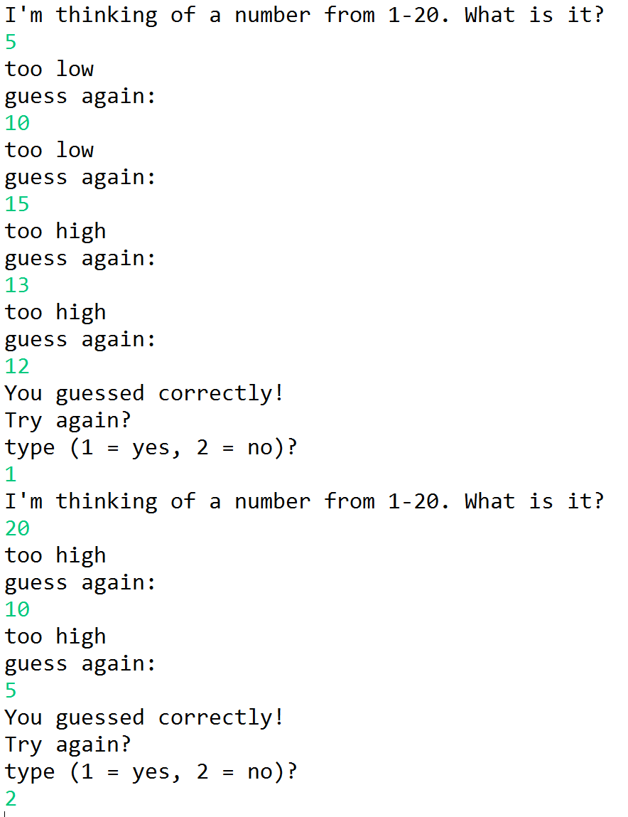**Output:**